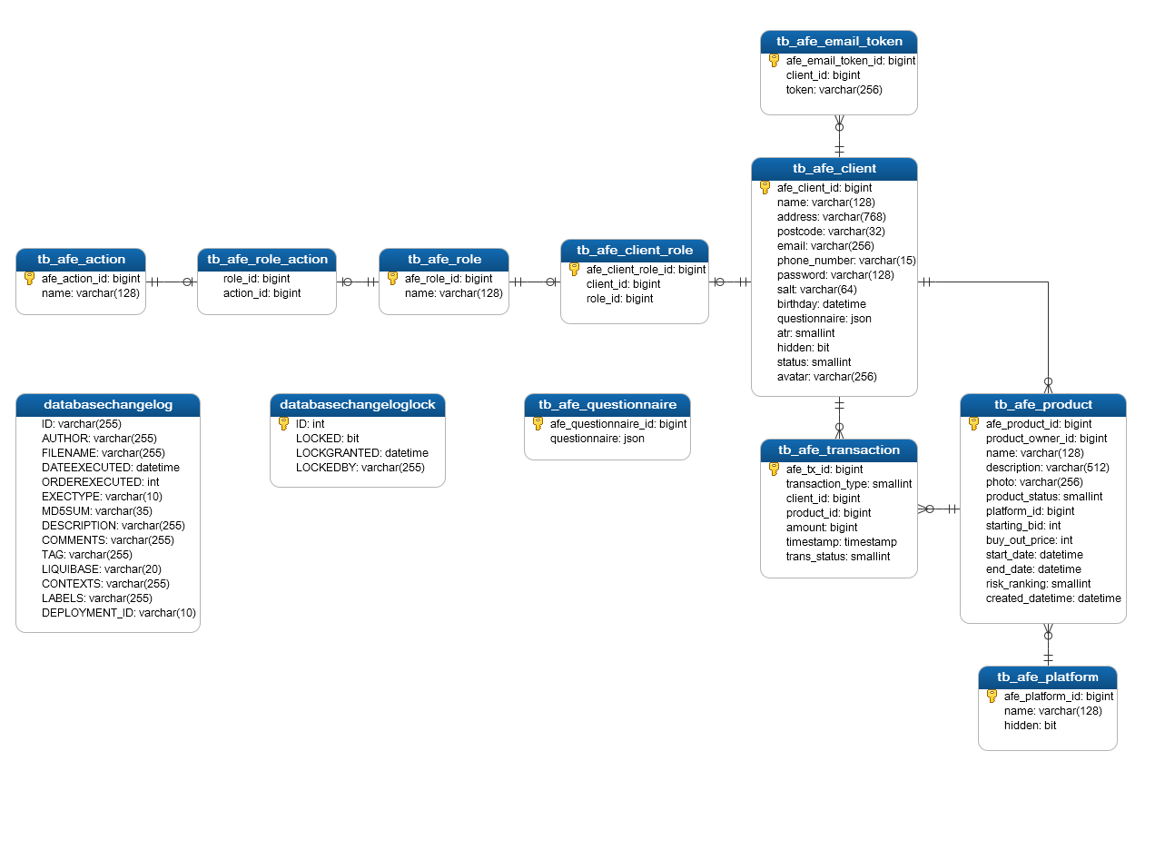

* **tb_afe_action** – Names of system actions
* **tb_afe_role_action** – Linking table. Contains information about what actions are allowed for different roles
* **tb_afe_role** – System roles. This is group of actions in fact
* **tb_afe_client_role** – Appointing of roles to users. One user can have any number of roles
* **tb_afe_client** – Clients
* **tb_afe_platform** – List of P2P/CF platforms
* **tb_afe_product** – Products
* **tb_afe_questionnaire** – Questoinnaire. Stored in JSON
* **tb_afe_transaction** – Syste transactions (bids in our case)
* **tb_afe_email_token** – Information about tokens for email verification. Is used to connect verification token with the client
* **databasechangelog** – tech table for storing the history of changes. More can be found in the documentaiton of Liquibase
* **databasechangeloglock** – technical table used for storing the flag of blocking the DB. More can be found in the documentation of Liquibase